COVID-19 and JobKeeper

What is JobKeeper?
- JobKeeper is a government program to try to help workers keep their jobs.
- Only some businesses are eligible and you should check if your employer is eligible.
- The government pays the employer $1,500 a fortnight JobKeeper payment for each eligible employee.
- $1,500 is paid to workers by their employers in the same way as wages so it will be taxed.
- JobKeeper is temporary and at the moment it is due to stop on 27 September 2020.
- An employer can’t pick and choose which employees get paid JobKeeper - if one eligible employee gets JobKeeper, all eligible employees should get it.

Are you eligible for JobKeeper?
To be eligible, you must meet the following requirements:
- You must be aged 16 or over.
- You must have been employed by the business as at 1 March 2020.
- You must be employed for any fortnight that the JobKeeper payment will be claimed for you
- You must be employed as a full time or part time employee. Casual workers must have been employed on a “regular and systematic basis” for at least 12 months as at 1 March 2020.
- You must be an Australian resident or special category visa holder.
- In general, employees on temporary visas are unlikely to be eligible.
- You must provide your employer with a completed nomination form.
- If you have more than one job, you can only apply for JobKeeper for one.
- Some workers can’t get it (for example, if you are getting workers compensation or paid parental leave)
JobKeeper Rules
- Employers can give ‘JobKeeper Enabling Directions’ which can mean you have to work less hours, or temporarily not come to work, or work different duties or at a different place than normal.
- Employers must talk to you about the change and tell you at least 3 days before the change is due to start.
- The changes must be safe and reasonable. If you need a particular qualification or licence to do the work, your boss can’t ask you to do the work unless you have that qualification or licence.
- Employers can ask you do agree to some other changes and your boss can tell you to take annual leave, as long as you will be left with at least 2 weeks, which you can’t unreasonably refuse to take.
- You and your employer can also agree that you take twice the annual leave at half the pay.
- You still work for your employer during this time, even if you are asked not to come to work, so you still earn annual leave etc.
- If you are told you must do something that you are concerned about, you should get legal advice as you may be able to dispute this by making a complaint can be made to the Fair Work Commission.
What do employees get paid under JobKeeper?

Situation | Pay each fortnight
Worker is told not to come to work –  temporarily ‘stood down’ | $1,500
Worker is on unpaid leave or on paid leave of less than $1,500 | $1,500
Worker is still working, earning less than $1,500 each fortnight | $1,500
Worker is still working (normal or reduced hours), earning more than $1,500 per fortnight | Full wages for the hours worked
Worker is on paid leave and should get paid more than $1,500 | Full wages they should get on paid leave

Examples

Jon works in a gym, 20 hours per week, earning $25 per hour. He usually gets paid $1000 before tax per fortnight. The gym was closed due to the Covid-19 government shutdown and Jon was told by his employer that he doesn’t have any work for Jon to do. The business and Jon qualify for JobKeeper. Although Jon usually only earned $1000 per fortnight, he will receive $1500 (before tax) per fortnight under JobKeeper.
Jen also works at the gym. She worked 38 hours per week, earning $25 per hour. She usually gets paid $1,900 before tax each fortnight. She also qualifies for JobKeeper, and there is also no work for her to do. Although Jen usually earned $1,900 per fortnight, she will only receive $1,500 (before tax) per fortnight from her employer, which she can get due to the JobKeeper scheme.
Jes works in a retail store that was not shut down but there has been a large downturn of work. She works 38 hours per week, earning $25 per hour. She usually gets paid $1,900 before tax each fortnight. She also qualifies for JobKeeper. She is still working the same hours at work. As Jes is entitled to get paid for all the work that she does, she still gets paid $1,900 per fortnight. Depending on when the business is eligible, her employer may be getting $1,500 of the amount paid to Jess per fortnight from the government through the JobKeeper scheme.

Where can I get help or more information
Kingsford Legal Centre – Legal Advice
- email legal@unsw.edu.au,
- complete the online form on our website or
- call (02) 9385 9566 (Monday- Friday 9am – 1pm, 2pm – 5pm)
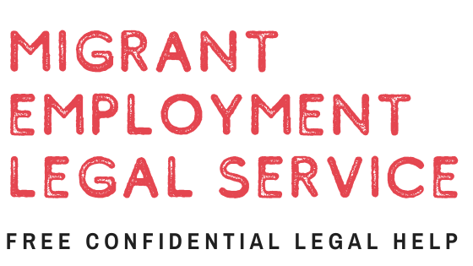 | Migrant Employment Legal Service- Legal Advice for Migrants  - Call (02) 8002 1203  Complete the online form on their website: https://mels.org.au/contact/
Your local community Legal Centre- Legal advice
- Call Law Access on 1300 888 529
- Visit the CLCNSW website: https://www.clcnsw.org.au/find-legal-help
Fair Work Australia (Information and complaint body)
- For information about making a complaint
- https://www.fairwork.gov.au/how-we-will-help/templates-and-guides/fact-sheets/rights-and-obligations/employment-conditions-during-natural-disasters-and-emergencies
- https://www.fwc.gov.au/resources/benchbooks/JobKeeper-disputes-benchbook

