COVID-19 and being stood down

What is a ‘stand down’ or being ‘stood down’?
- Being stood down broadly means that your employer has told you that you no longer need to come into work for a temporary period of time due to particular circumstances.
- Employers are only allowed to stand down their workers in certain circumstances.
- There are now 2 lawful ways an employer can stand down an employee:-
  - Under general stand down rules- this existed before COVID-19;
  - Under a ‘JobKeeper Enabling Stand Down Direction’- a temporary addition to employment law.

Stand down 1: General stand down rules
- There needs to be:
            - a stoppage of work;
            - that the employer is not reasonably responsible for, and
            - no useful work for the employee to do

- Before you are stood down you can ask to take leave instead of being stood down.
- You can’t be stood down when on approved leave.
- You remain an employee and still accrue leave entitlements.
- You do not go to work and you do not get paid (unless you can under the JobKeeper scheme).
- If you disagree with the employer decision, you can dispute it to the Fair Work Commission.
Note: If an employee has an enterprise agreement or employment contract, it may change the requirements.

Examples
 | LAWFUL: The employer has to close the business due to a government shutdown |  | UNLAWFUL: There is a downturn in sales so the employer thinks it is not economical for the employee to keep working.
 | Jon works in a gym which is closed due to the Covid-19 government shutdown. Jon is told by his employer that he has to stop his business and doesn’t have any work for Jon to do. This is a lawful stand down as the employer cannot choose to keep his gym open, the employer has no control over this.
 | Jes works in a retail store that was not shut down but there has been a large downturn of work. Her employer has decided that they don’t need as many staff, it is not profitable to keep the store Jes is working in open. Jes is told she is stood down. This is not a lawful stand down as the employer has made an economic choice not to open a store, the employer has control over whether or not to open the store.

Stand down 2: ‘JobKeeper Enabling Stand Down Direction’

- A ‘JobKeeper Enabling Stand Down Direction’ is a direction by an employer on an employee.
- The employer must be:-
    - eligible for JobKeeper scheme at the time of the direction, and
    - eligible for JobKeeper payments for the employee for the relevant period.

- The direction can only be made if the employee cannot be usefully employed for their normal days or hours because of changes to business attributable to:
- the COVID-19 pandemic; or
- government initiatives to slow the transmission of COVID-19.

- The JobKeeper enabling stand down direction is for the employee not to work on a day or days on which the employee would usually work; or work for a lesser period than they would ordinarily work; or work less hours, which can be nil.
- The employer must satisfy the wage condition, pay the employee either the JobKeeper payment or for work performed (whatever is greater) and give the employee the same hourly pay.
- The direction must be safe, having regard to but not limited to nature and spread of COVID-19.
- An employee can ask to take any paid or unpaid leave before or during the stand down.
- An employee can’t be stood down when on approved leave or authorised absence from work.
- The employee remains an employee and stills accrue leave entitlements.
- If you disagree with the employer decision, application is to the Fair Work Commission

Example

Jen also works at a gym. Both her and the employer qualify for JobKeeper. As a government initiative to slow down the transmission of COVID-19 gyms cannot open. Her employer has issued a ‘JobKeeper Enabling Stand Down Direction’ on Jen. Although Jen usually earned $1,900 per fortnight, she will only receive $1,500 (before tax) per fortnight from her employer, which she can get due to the JobKeeper scheme. (See COVID-19 Employment Fact Sheet 2 June 2020 for information about JobKeeper payments).

Where can I get help or more information

Kingsford Legal Centre – Legal Advice
- email legal@unsw.edu.au,
- complete the online form on our website or
- call (02) 9385 9566 (Monday- Friday 9am – 1pm, 2pm – 5pm)
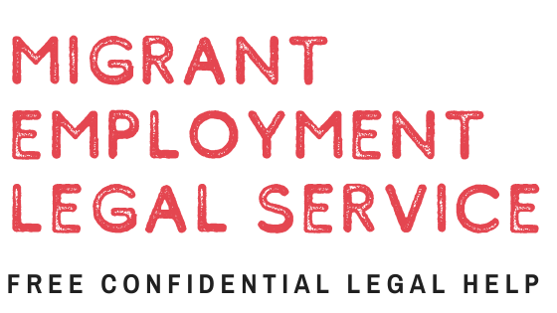 | Migrant Employment Legal Service- Legal Advice for Migrants  - Call (02) 8002 1203  Complete the online form on their website: https://mels.org.au/contact/
Your local community Legal Centre- Legal advice
- Call Law Access on 1300 888 529
- Visit the CLCNSW website: https://www.clcnsw.org.au/find-legal-help
Fair Work Australia (Information and complaint body)
- For information about making a complaint
- https://www.fairwork.gov.au/how-we-will-help/templates-and-guides/fact-sheets/rights-and-obligations/employment-conditions-during-natural-disasters-and-emergencies
- https://www.fwc.gov.au/resources/benchbooks/JobKeeper-disputes-benchbook

